Assert consultation on terminology
Quantitative Results
Question 1
Total participants 77
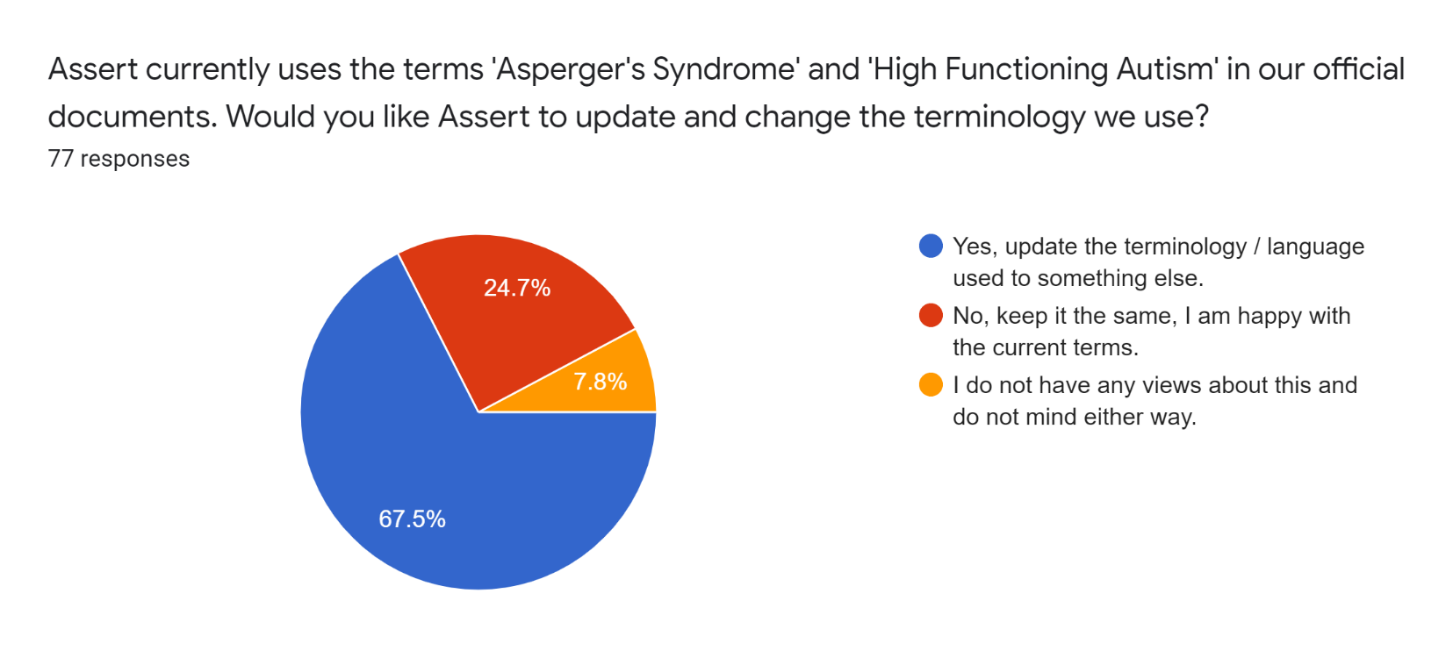

Summary | Count
Yes, update the terminology / language used to something else. | 52
No, keep it the same, I am happy with the current terms. | 19
I do not have any views about this and do not mind either way. | 6
TOTAL | 77

Question 2
Total 76 responses
What is your preferred terminology?
The 3 groupings are:
- All respondents.
- Respondents who answer ‘ Yes, update terminology’ only.
- Respondents who answer ‘No, do not update terminology’ + ‘I do not have any views’.
Tab 6. Comparison of the three groups
Terms | All | Only Yes | Don't change & no opinion
Asperger’s Syndrome | 11 | 8 | 3
Aspie(s) and Aspie as noun and adjective | 1 | 0 | 1
Autism | 29 | 23 | 6
Autistic (as a noun as well as an adjective with the noun plural being “Autistics”) | 46 | 31 | 15
Autistic Person / People | 2 | 2 | 0
Autistic Spectrum Condition | 34 | 23 | 11
Neuro Diverse | 1 | 1 | 0
TOTAL | 124 | 88 | 36

